Notes for Router Hack Day 2


Access your router’s serial shell
Disassemble your router. You’ll need to remove a screw on the bottom, which is covered by a sticker.
Cut the ends off three DuPont jumper wires, leaving port connectors on the other ends.
Solder the stripped wires to the terminal points pictured below, located in the middle of the circuit board.
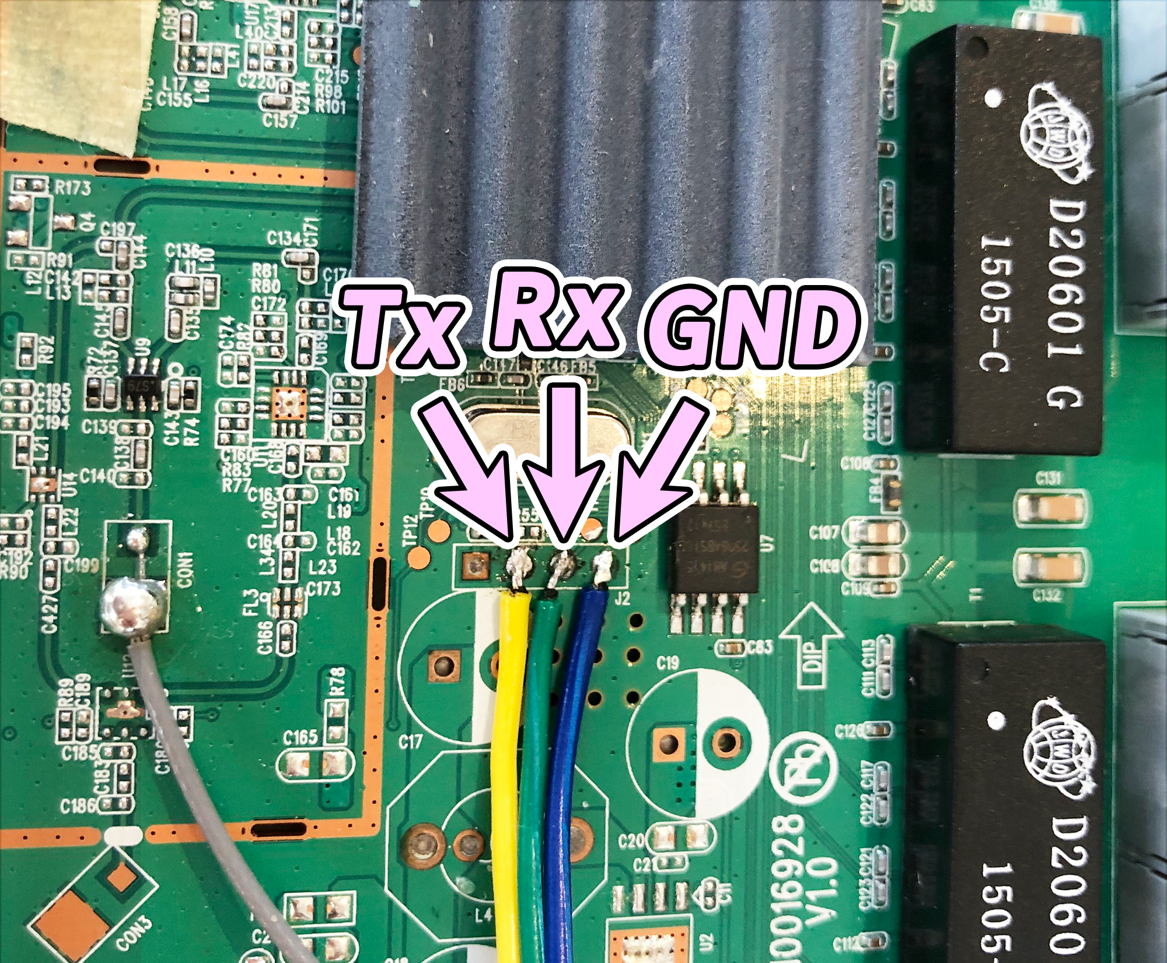
Connect the terminal labeled Tx in the image above to the pin labeled Rx on your USB serial interface. Next, connect Rx from the router to Tx on the USB serial interface. Then connect GND to GND.
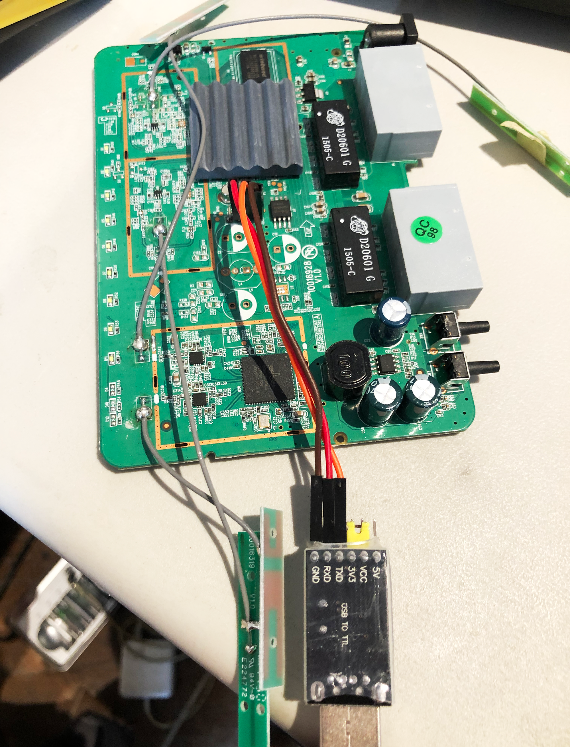
Plug the USB serial interface into your computer.
Plug in the router.
Run the following command to see if your USB serial interface is connected.
ls /dev/ttyUSB*

sudo apt-get autoremove brltty

You can use these commands to get info about connected USB devices:
lsusb
dmesg

Command for opening serial connection with router:
minicom -D /dev/ttyUSB0 -c on
Press CTRL+A, then press O to open the configuration menu. Use the arrow keys to select Serial port setup. Press enter.

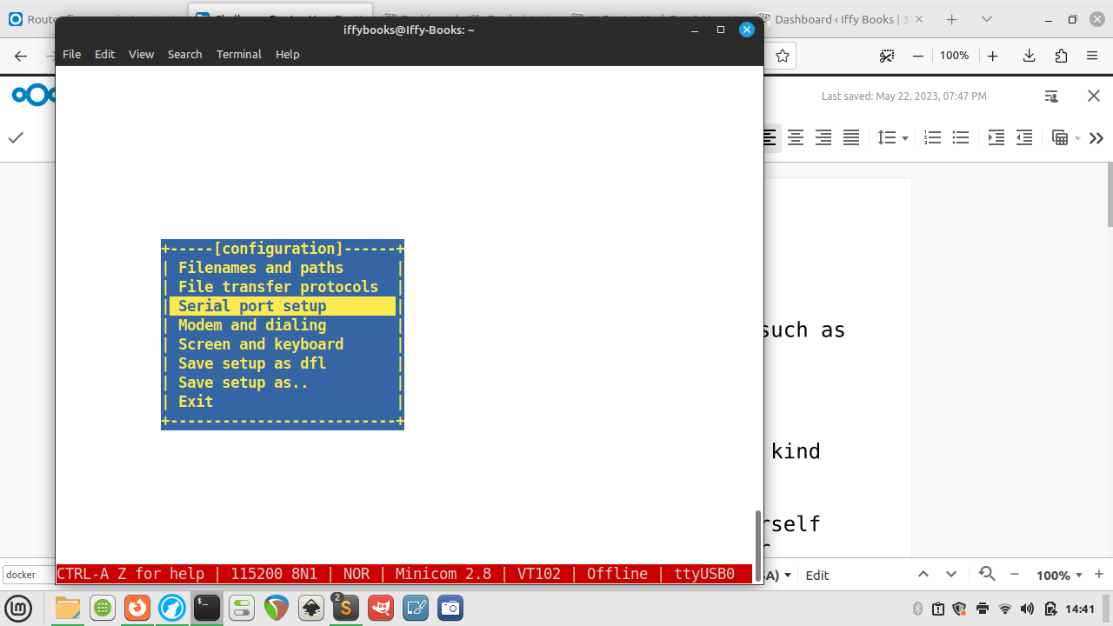

Press F to switch Hardware Flow Control to No.

Before:
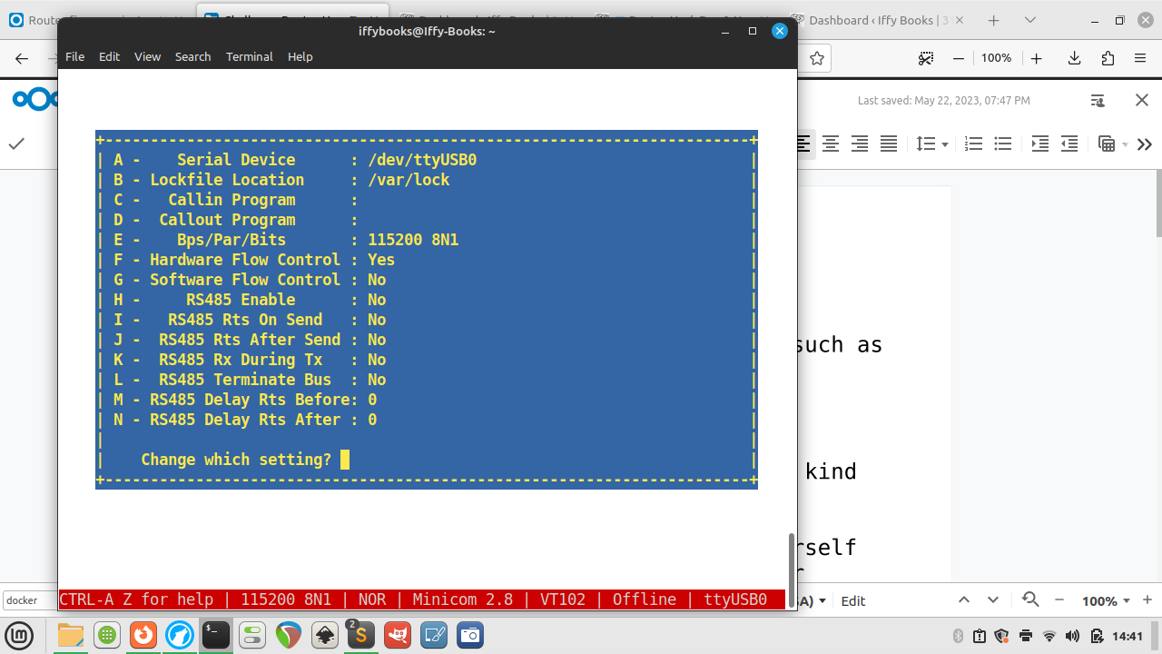
After:
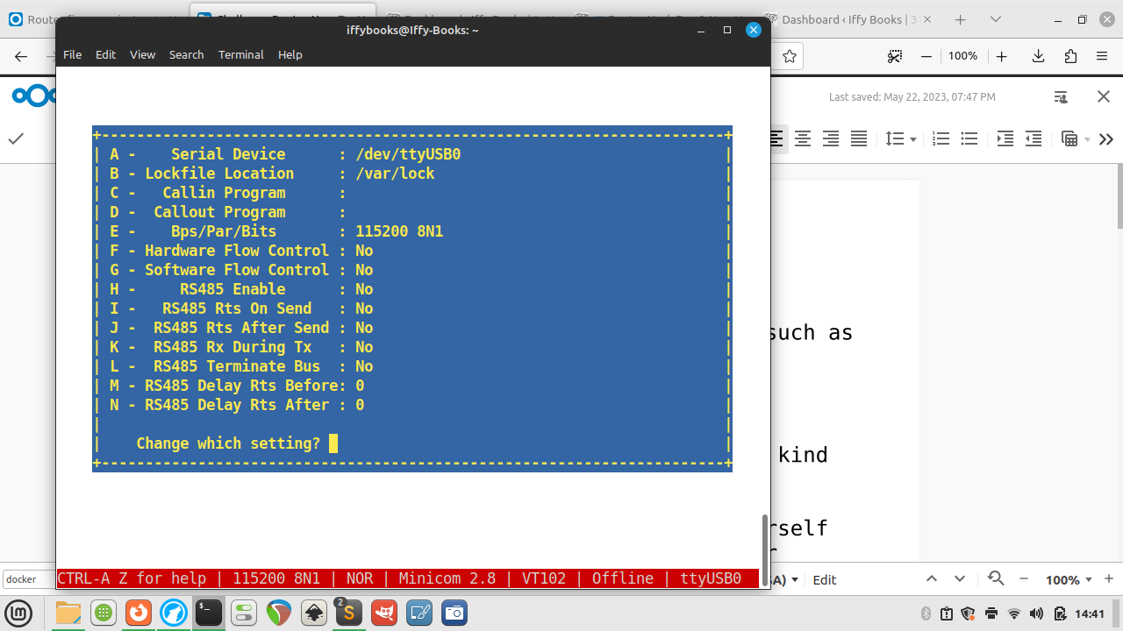
Press enter to close the serial port setup menu.

To save this setting as your default, use the down arrow to select Save setup as dfl. Press enter to save.

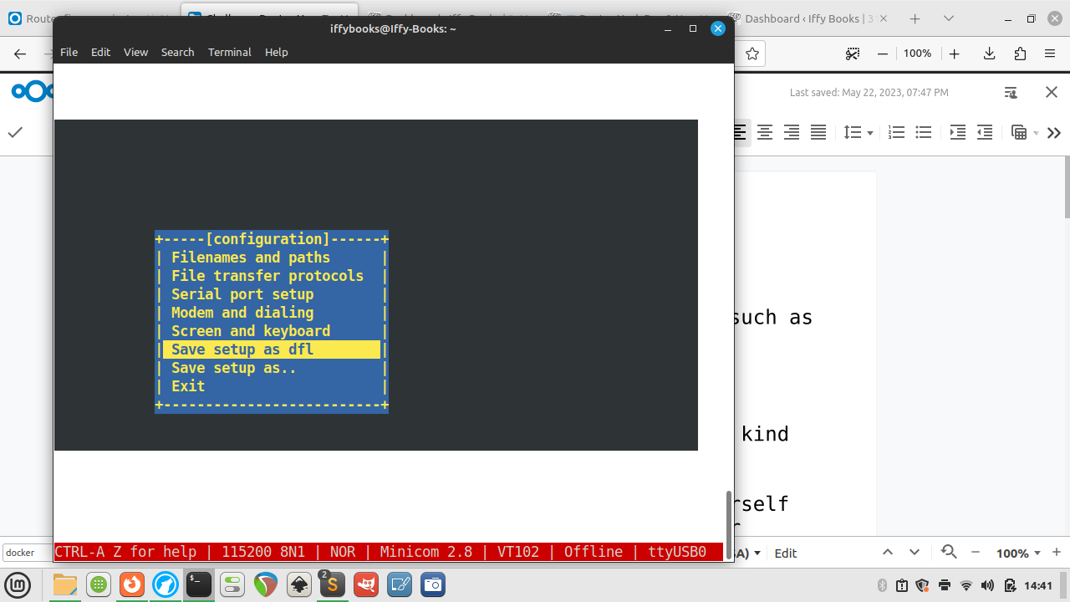
Use the arrow keys to select Exit, then press enter.

Press enter and you’ll be prompted to log in.
username: root
password: Fireitup

Press tab twice in a row to see a list of available software.

Restart your router while the USB serial connector is attached and you’ll see a waterfall of interesting startup info:
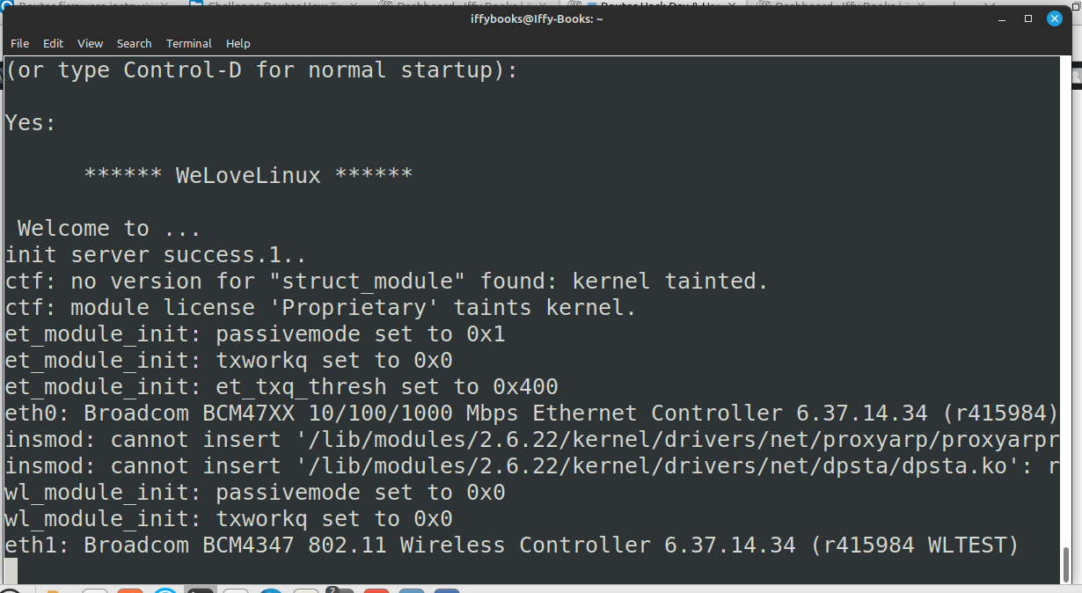

To get your router’s SSID name, use the command wl status.
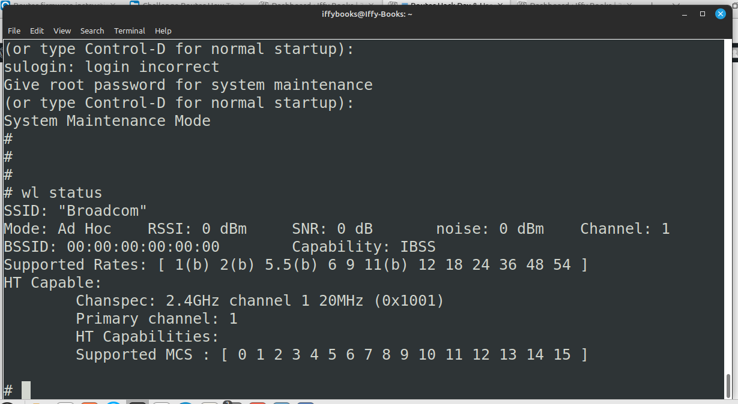

Creating 8 MTD partitions on "sflash":

[what's on the flash device]

binwalk -Me .....bin

CRC value tells us the checksum of everything after HDR0

OpenWRT has tools to do this.

dd for manipulating the firmware

40 hex bytes at a time, but skip first 40 bytes:

dd if=US_FH1201V1.0BR_V1.2.0.14\(408\)_EN_RD.bin of=data bs=$((0x40)) skip=1

In CFE mode, give yourself an IP address
Like 192.168.1.X
Then go to 192.168.1.1 and upload TRX firmware file

Remove

TRX format starts with HR0 in all caps

trx format

#########

Mount file system in serial shell:

mount -t usbfs none /proc/bus/usb/

Show connected USB devices:
cat /proc/bus/usb/

Do a web search for vendor id number and prodID number to get the chip details

Wireless adapter:

BCM43526

[
SOIC8
square next to serial connectors, which contains the firmware
]

SOIC:
25q64b

[CH341 is the tool to flash the firmware chip itself]

Main CPU:
BCM5357

32-bit little endian

go to buildroot dir
make menuconfig

target options -- MIPS little endian

toolchain --> change c compiler to musl

build options --> switch libraries to static only

target packages -> networking applications -> enable tcpdump (press space)

save and exit

make tcpdump

Download router firmware
Here’s the stock firmware that comes with the router:
Atlas Media AMW-DBR1200AC Firmware:
https://iffybooks.net/wp-content/uploads/2023/05/AtlasMedia_AC1200_FirmwareV1.4.bin
And here are two firmware releases from Tenda that work with the router. You’ll need to extract the files after downloading.
Tenda FH1201 Firmware V1.2.0.8_EN:
https://www.tendacn.com/us/download/detail-2123.html
Tenda FH1206 Firmware V1.2.0.8(8155)_EN:
https://www.tendacn.com/us/download/detail-2344.html
Download the Tenda FH1206 firmware, or your firmware of choice from the list above.
Decompress the RAR files you downloaded from Tenda’s site, giving you a firmware file with a name like US_FH1206V1.0BR_V1.2.0.8(8155)_EN_TD.bin. If you don’t already have a program installed for decompressing RAR files, you can use one of the following:
MacOS: The Unarchiver https://theunarchiver.com
Windows: WinRAR https://www.win-rar.com
Linux: unrar https://linux.die.net/man/1/unrar

Upload new firmware through the router admin panel

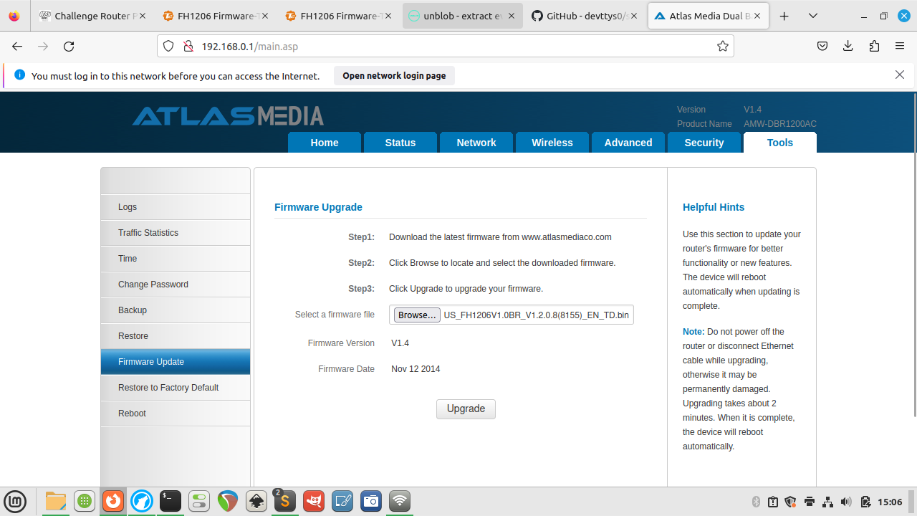

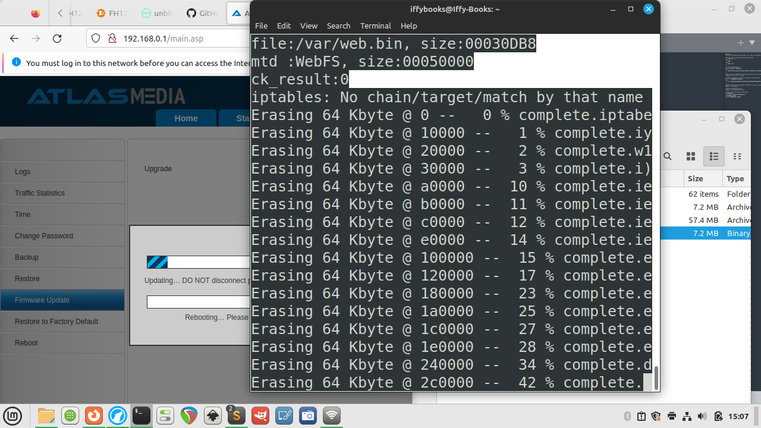

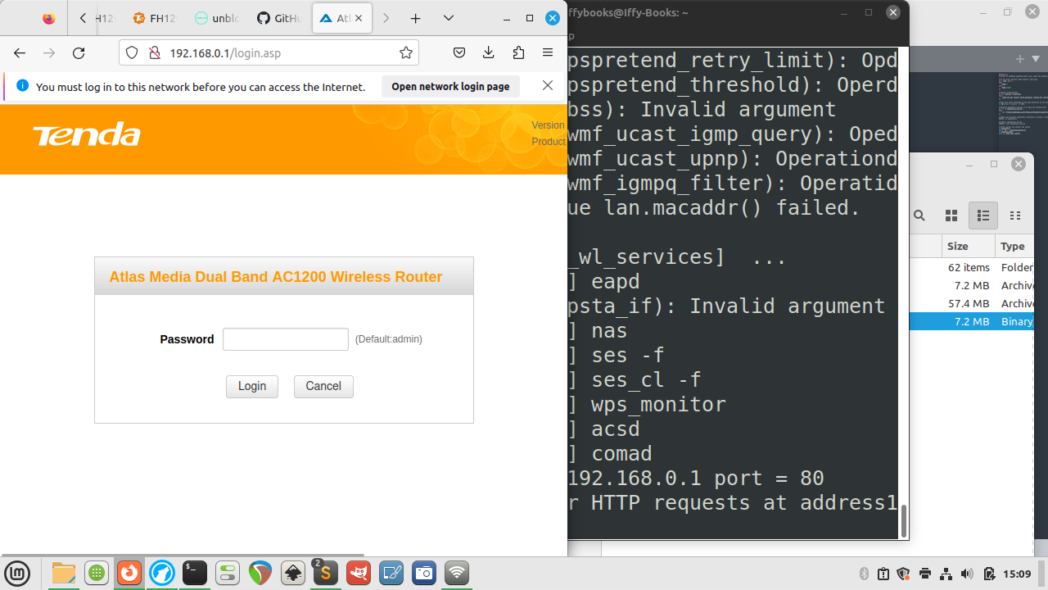

Decompress the router firmware
These instructions are from Jim. Thanks, Jim!

clone the repo
git clone https://github.com/devttys0/sasquatch.git

then cd in to sasquatch directory

the README mentions this as a pre-req, so do this
sudo apt-get install build-essential liblzma-dev liblzo2-dev zlib1g-dev

if you run ./build.sh at this point you will get a bunch of errors related to xz_wrapper and LZMA
eventually it ends in something like this:

xz_wrapper.c:462:20: error: ‘LZMA_BUF_ERROR’ undeclared (first use in this function)
462 | } else if(res != LZMA_BUF_ERROR)
| ^~~~~~~~~~~~~~
xz_wrapper.c: In function ‘xz_uncompress’:
xz_wrapper.c:494:2: error: unknown type name ‘lzma_ret’
494 | lzma_ret res = lzma_stream_buffer_decode(&memlimit, 0, NULL,
| ^~~~~~~~
xz_wrapper.c:494:17: error: implicit declaration of function ‘lzma_stream_buffer_decode’ [-Werror=implicit-function-declaration]
494 | lzma_ret res = lzma_stream_buffer_decode(&memlimit, 0, NULL,
| ^~~~~~~~~~~~~~~~~~~~~~~~~
xz_wrapper.c:497:12: error: ‘LZMA_OK’ undeclared (first use in this function)
497 | if(res == LZMA_OK && size == (int) src_pos)
| ^~~~~~~
xz_wrapper.c:503:1: error: control reaches end of non-void function [-Werror=return-type]
503 | }
| ^
cc1: all warnings being treated as errors
make: *** [<builtin>: xz_wrapper.o] Error 1

open the patch file in ./patches/patch0.txt and find this section

# To build using XZ Utils liblzma - install the library and uncomment
# the XZ_SUPPORT line below.
#
-#XZ_SUPPORT = 1
+XZ_SUPPORT = 1

It will be around line 38087 of the 38726, so pretty close to the bottom of the file

change the line from
+XZ_SUPPORT = 1
to
+XZ_SUPPORT = 0

then run ./build.sh again

this time it works successfully and end in something like this

make[1]: Entering directory '/AC1200/sasquatch/squashfs4.3/squashfs-tools/LZMA/lzmadaptive/C/7zip/Compress/LZMA_Lib'
make[1]: Nothing to be done for 'all'.
make[1]: Leaving directory '/AC1200/sasquatch/squashfs4.3/squashfs-tools/LZMA/lzmadaptive/C/7zip/Compress/LZMA_Lib'
cc -g -O2 -I. -I./LZMA/lzma465/C -I./LZMA/lzmalt -I./LZMA/lzmadaptive/C/7zip/Compress/LZMA_Lib -D_FILE_OFFSET_BITS=64 -D_LARGEFILE_SOURCE -D_GNU_SOURCE -DCOMP_DEFAULT=\"gzip\" -Wall -Werror -DGZIP_SUPPORT -DLZMA_SUPPORT -DLZO_SUPPORT -DXATTR_SUPPORT -DXATTR_DEFAULT -c -o lzma_wrapper.o lzma_wrapper.c
g++ ./LZMA/lzmalt/*.o unsquashfs.o unsquash-1.o unsquash-2.o unsquash-3.o unsquash-4.o swap.o compressor.o unsquashfs_info.o gzip_wrapper.o lzma_wrapper.o ./LZMA/lzma465/C/Alloc.o ./LZMA/lzma465/C/LzFind.o ./LZMA/lzma465/C/LzmaDec.o ./LZMA/lzma465/C/LzmaEnc.o ./LZMA/lzma465/C/LzmaLib.o lzo_wrapper.o read_xattrs.o unsquashfs_xattr.o -lpthread -lm -lz -L./LZMA/lzmadaptive/C/7zip/Compress/LZMA_Lib -llzmalib -llzo2 -o sasquatch
mkdir -p /usr/local/bin
cp sasquatch /usr/local/bin

now when you run binwalk on the firmware dump file it will extract as expected

binwalk -eM flash.bin

now the squashfs-root directory contains the files from the router

notably, check out the passwd and shadow files

$ find . | egrep "passwd|shadow"
./squashfs-root/etc_ro/passwd
./squashfs-root/etc_ro/passwd_private
./squashfs-root/etc_ro/shadow
./squashfs-root/etc_ro/shadow_private
./squashfs-root/usr/bin/passwd
./squashfs-root/usr/sbin/chpasswd
./squashfs-root/var/etc/passwd
./squashfs-root/var/etc/passwd_private
./squashfs-root/var/etc/shadow
./squashfs-root/var/etc/shadow_private

Install and configure buildroot

Go to buildroot.org and click Download. Download and extract the package.
cd to the directory you just created. Then run the command make menuconfig.

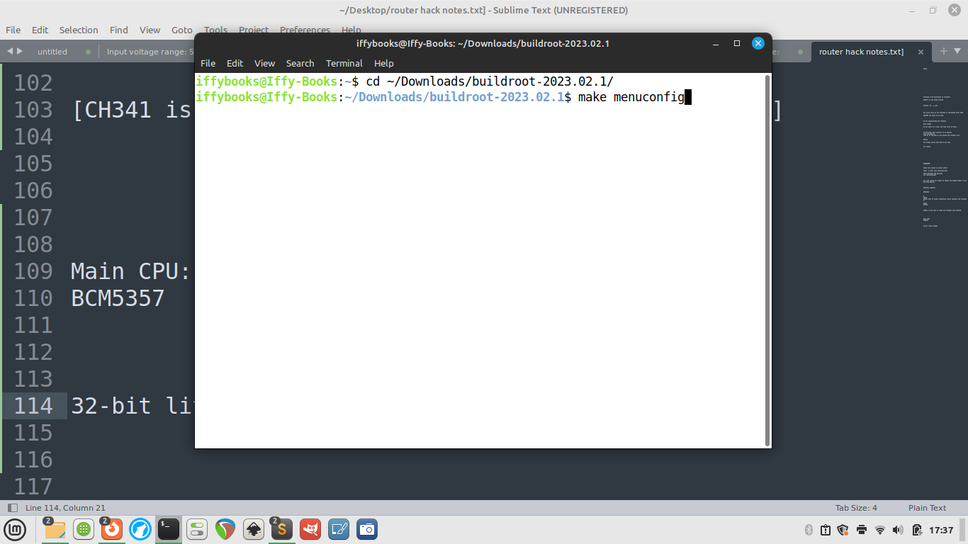

Go to Target options > Target Architecture and select MIPS (little endian).

Go to Toolchain > Toolchain type and switch the C library to musl.

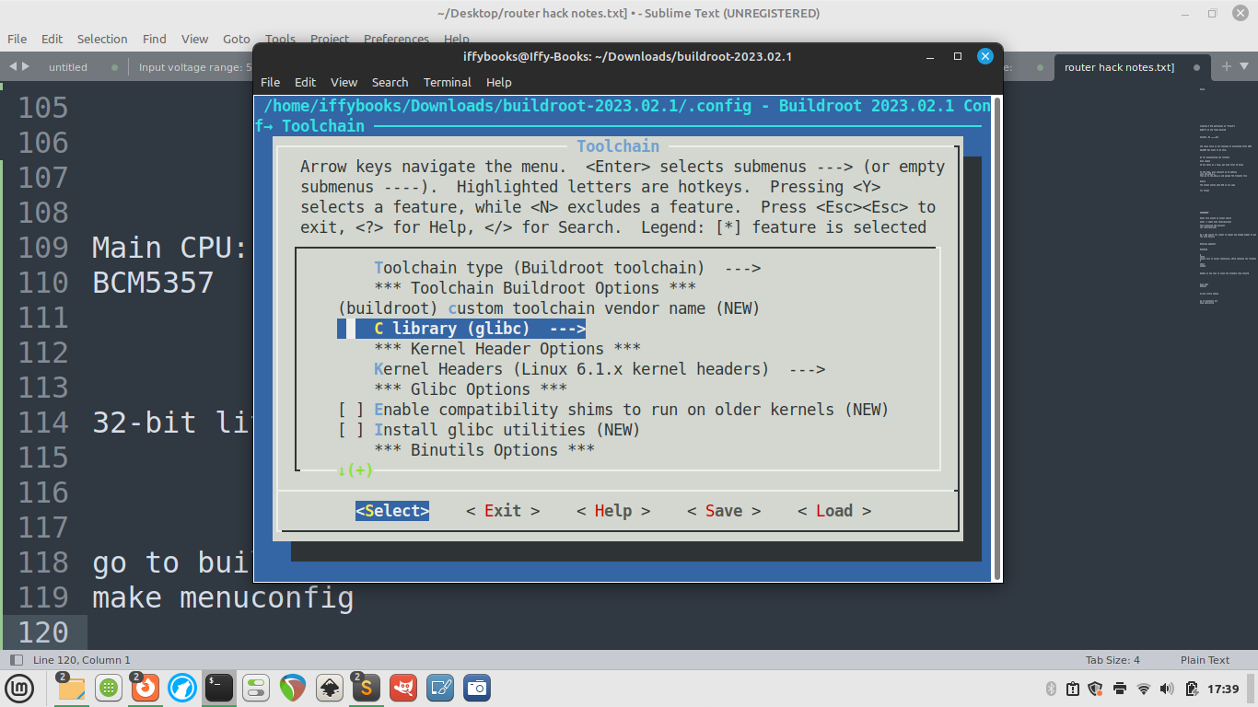

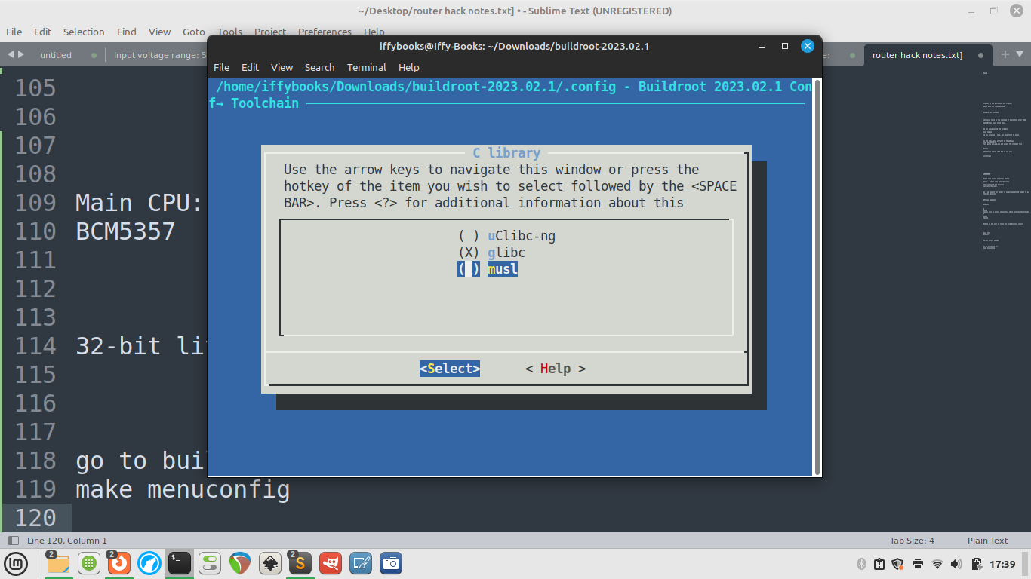

Select Exit to go back to the main menu.

Go to Build options and set libraries to shared only.

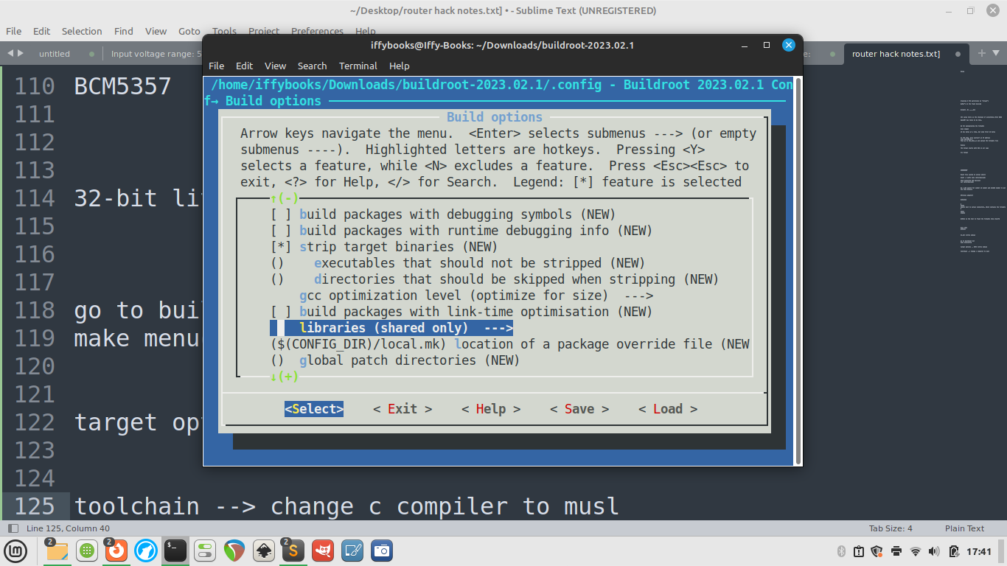

Go back to the main menu and use the left and right arrow keys to select Save. Select OK and press enter.
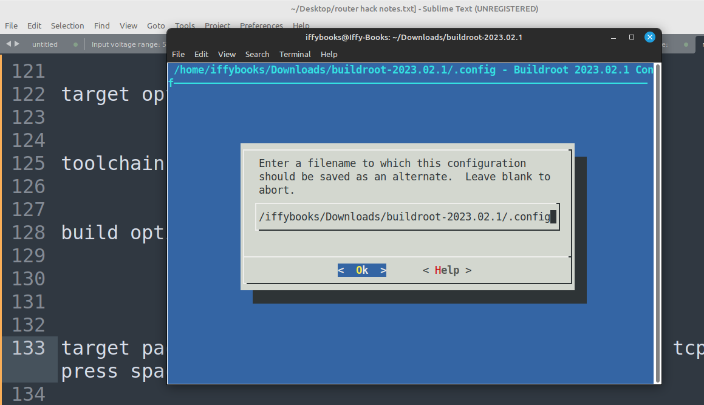

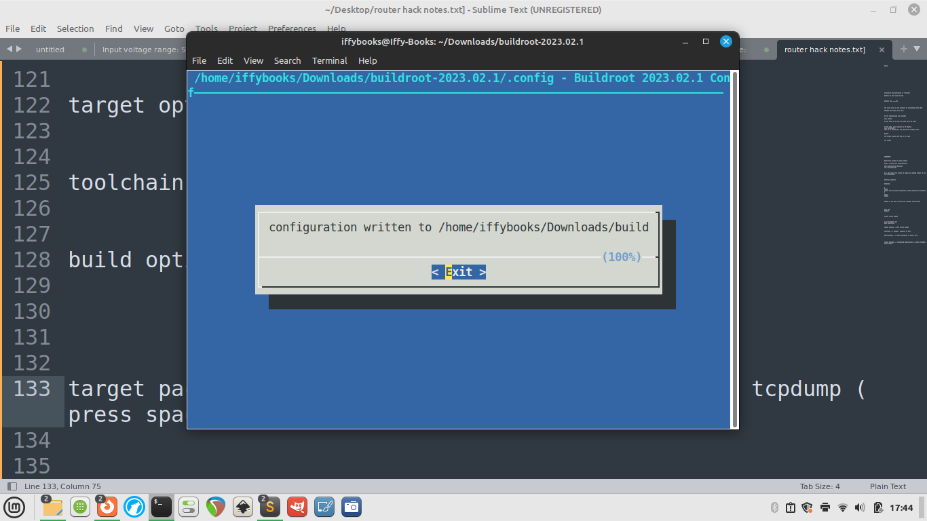
Select Exit to close the menuconfig tool.

Next, run the command make tcpdump. It will take a while, possibly 20 minutes or more.



